Homework 3:
Data management and visualizing data with ggplot2
due September 28, 2026
The first part of the assignment involves the final bits of data management that we covered in weeks 2 and 3; you will do these things with the data frame that you created yourself for the homework of week 2.
The second part of the assignment involves the use of the qplot() and ggplot() functions to create various graphical representations of data. For this assignment you will need to install and load the ggplot2 and ggthemes packages. You will use a dataframe that is included in the ggplot2 package, named mpg. This is a rather large datafile, so you will also get to practice creating subsets of dataframes based on specific characteristics.

PART A: Finishing up the data management part
1. As part of the homework assignment of week 2, you created a data frame with different types of variables (including repeated-measures and a continuous demographics variable), and then you turned that originally wide data frame into long format. Please use the long-format data frame for this assignment: Use the command recode() to add a new categorical factor to the long data frame. This new factor should be based on your continuous demographic variable (IQ or height or age or whatever it was in your own data frame); the new factor should have at least 4 different levels. Please copy/paste the relevant R code here.
install.packages("car")
library(car)
range(df_long_1$age) # 20-39
recode() # age continuous demographic variable => categorical factor with four different levels
df_long_1$f_age <- as.factor(recode(df_long_1$age, "20:25 = 'young'; 26:30 = 'mid-young'; 31:35 = 'mid-old'; 35:40 = 'old'"))
str(df_long_1)
table(df_long_1$f_age)

> table(df_long_1$f_age)
mid-old mid-young old young
6 6 6 12

2. Based on what you did for point 1. above, create now a new data frame from which the rows corresponding to 2 levels of this new categorical variable have been removed. For example, let's say the previous data frame had rows of data with low, medium, high, and genius IQ. Then please create now a new data frame that has only the rows corresponding to 2 of these levels (for example only genius and medium). Make sure to use the command droplevels() to remove the unused factor levels. Check to make sure that the unused levels have indeed been removed. Please copy/paste the relevant R code here.
Hint: There are different ways to do this; we talked about them in week 2 of the course, so perhaps have a look again at these slides (it was towards the end of this lecture somewhere around slides 80 to 85 or so), in case you are struggling.
df_subset <- df_long_1[-which(df_long_1$f_age %in% c("mid-old", "mid-young")), ]
df_subset
> df_subset
pp_code gender age variable value f_age
1 1 f 39 FAT_1 6 old
3 3 m 25 FAT_1 7 young
4 4 m 20 FAT_1 6 young
5 5 f 24 FAT_1 8 young
8 8 f 37 FAT_1 9 old
9 9 f 22 FAT_1 5 young
11 1 f 39 FAT_2 8 old
13 3 m 25 FAT_2 6 young
14 4 m 20 FAT_2 6 young
15 5 f 24 FAT_2 9 young
18 8 f 37 FAT_2 10 old
19 9 f 22 FAT_2 10 young
21 1 f 39 FAT_3 9 old
23 3 m 25 FAT_3 8 young
24 4 m 20 FAT_3 8 young
25 5 f 24 FAT_3 9 young
28 8 f 37 FAT_3 8 old
29 9 f 22 FAT_3 9 young

PART B: Visualizing data with qplot() from the package ggplot2
Before you start, 2 tips:
- As you will see below, for the rest of the homework, we several times will ask you to insert your figures into your answer document. In terms of adding the figure number, the figure header, and the note below the figure (all in APA style): I find it easiest to create only the figure itself in R (without header, number, etc). Then I insert that figure (as a pdf or jpg file for example) into the Word document and then create in Word the figure number, the figure header, and the note. This works best for me, but if you prefer to do it differently, then that's of course also fine.
- For the first few points in this homework, you will work with a data frame that is automatically installed when you install ggplot2. It's called mpg and is a large data set that contains data about different car types and how much gasoline the different cars use in different situations. As always when you encounter a new data frame, it is a very good idea to inspect the structure, so you know the number of rows and columns, the names and types (classes) of variables (i.e., factors, numeric, etc.), and the numerical descriptions of the variables. Thus, we highly recommand that you first use commands like summary(), str(), head(), and tail() to familiarize yourself with the data frame mpg. Please note that you first might have to install and/or load the package ggplot2, if you have not yet done so. If you want some short information about the various variables in the mpg data frame, have a look at the mpg helpfile, e.g., by running ?mpg

- Create two boxplots with qplot(): One showing the city mileage for each car manufacturer and one showing the highway mileage for each car manufacturer. Please copy/paste the R code and also include the actual figures (with figure number, title, and note in APA style). Please also describe in a sentence or two what you see in the boxplots.
Figure 1
The city mileage of each car manufacturer
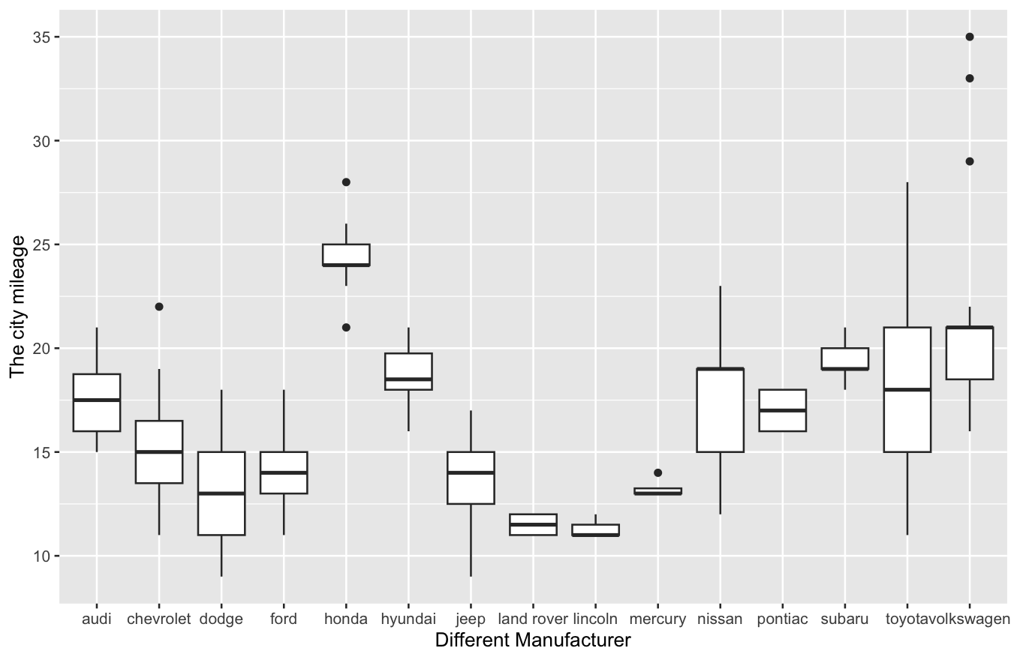
Note. The specific city mileage of each car manufacturer are shown above.
Figure 2
The highway mileage of each car manufacturer
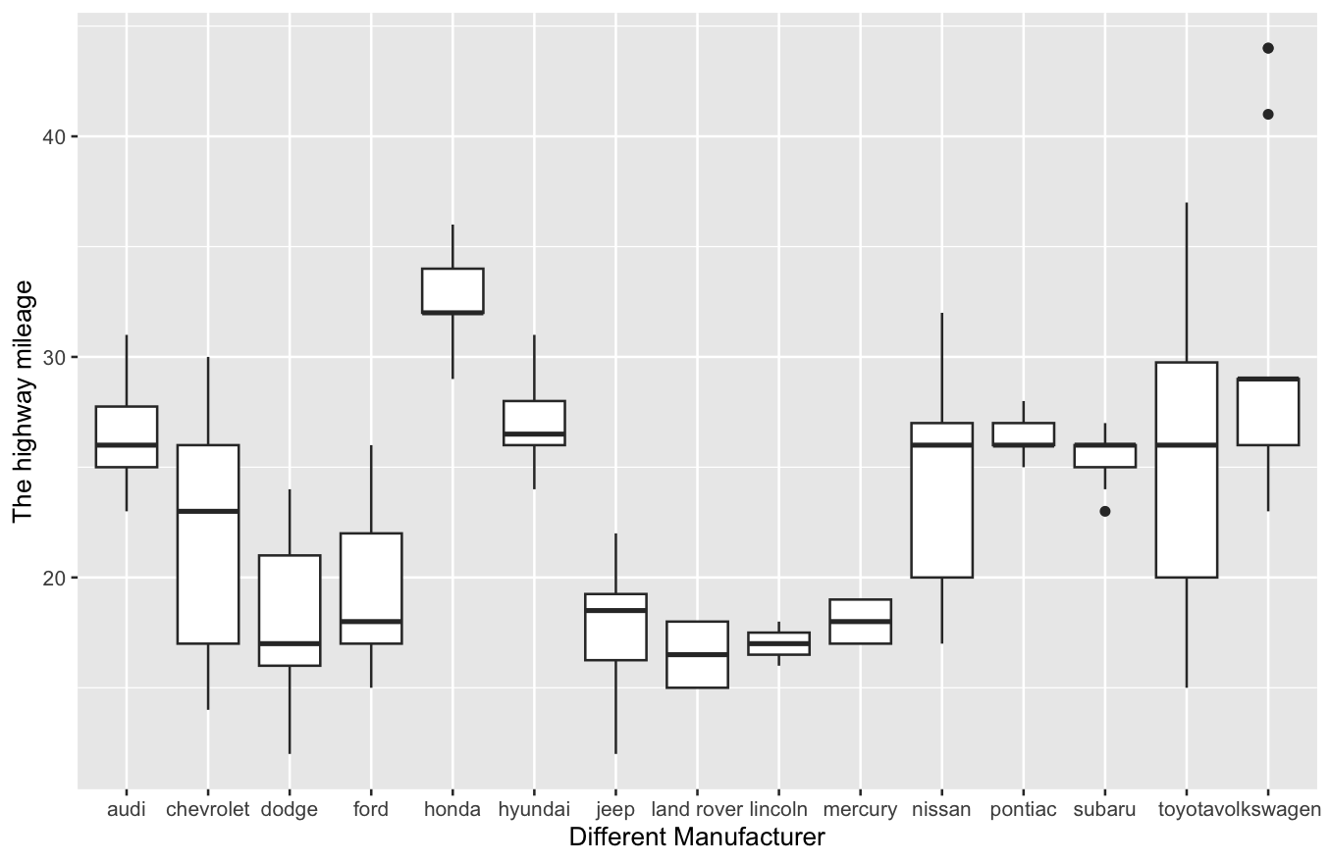
Note. The specific highway mileage of each car manufacturer are shown above.
4. Provide the R code that creates a new dataframe that only includes the four manufacturers Volkswagen, Ford, Honda, and Toyota.
Sometimes you want to exclude some data in order to focus on different subsets of an entire dataframe. There are several ways to accomplish this in R, for example with either subset(), which(), or %in% (feel free to use the command you prefer most or to try out all 3 of them). In any case, do not forget to use droplevels(). For this part of the assignment, create a subset of the mpg dataframe that only includes the rows of data with the following four manufacturers: Volkswagen, Ford, Honda, and Toyota; Let's call this reduced data frame mpgsmall. Please copy/paste your R code here.

df_subset_VFHT <- mpg[which(mpg$manufacturer %in% c("volkswagen", "ford", "honda", "toyota")), ]
df_subset_VFHT

- Create a single graph using qplot() that shows the distributions for city mileage for each of the four manufacturers in the subsetted dataframe with differently colored density plots (i.e., 4 different lines within the same plot). Then do the same, but with a histogram using faceting. Please copy/paste the R code and also include the actual figures (with figure number, title, and note in APA style). Please also provide a brief description of which of the two graphs you find easier to interpret.
Figure 3
The density distributions for city mileage of four manufacturers
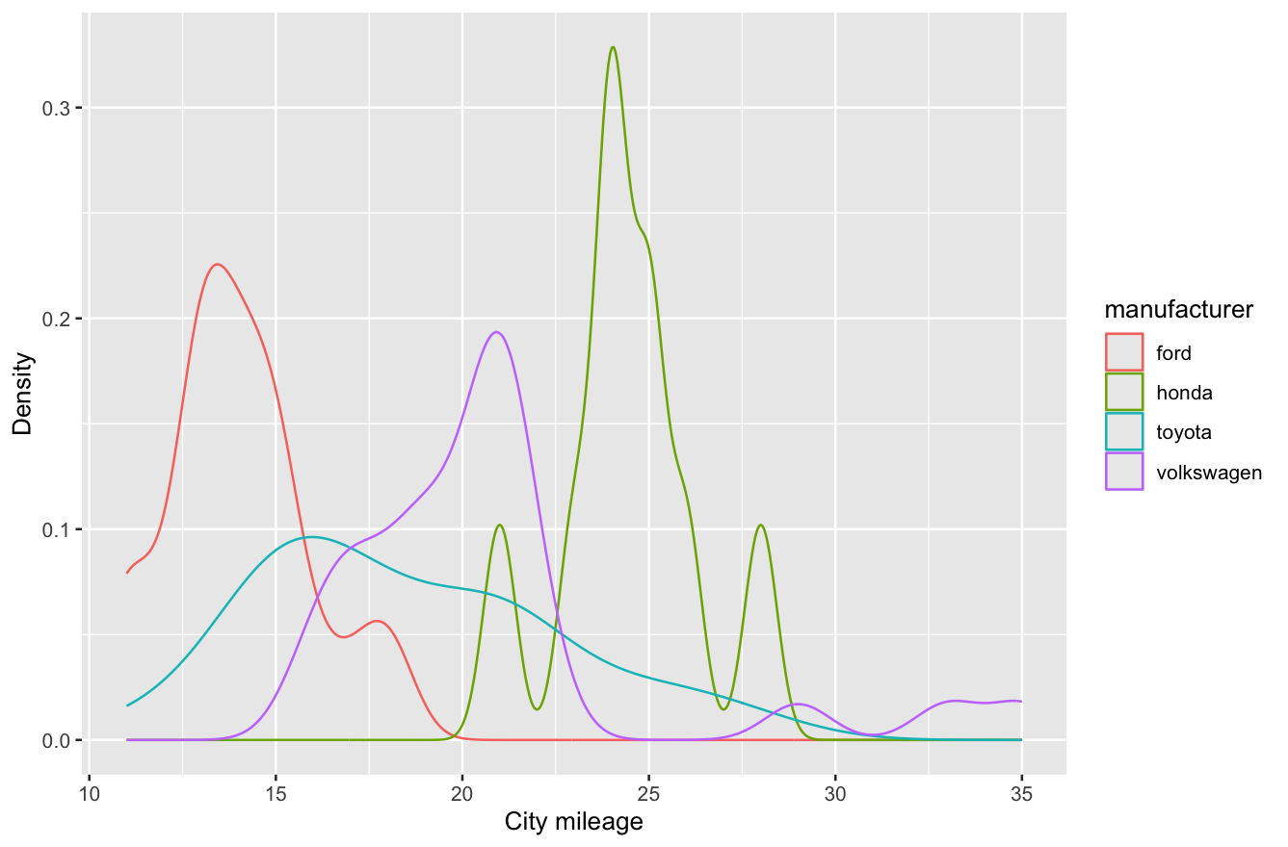
Note. The city mileage of each car manufacturer are shown above.

Figure 4
The histogram distributions for city mileage of four manufacturers

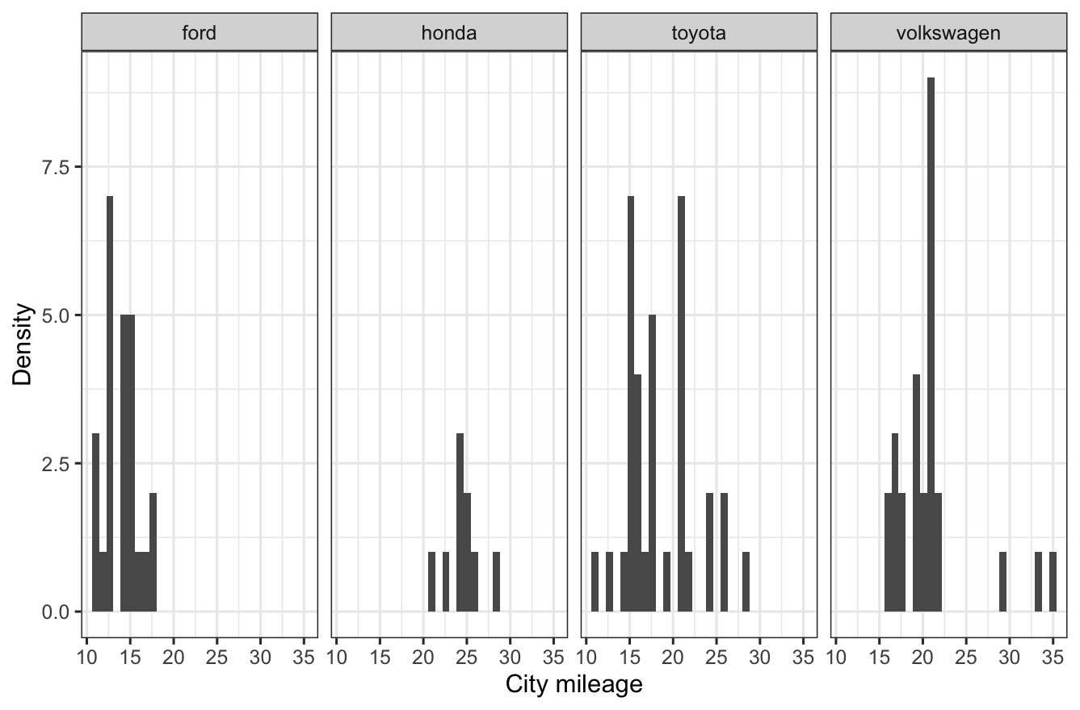
Note. The city mileage of each car manufacturer are shown above.
- Create a scatter plot to show the relation between city and highway mileage in the subsetted dataframe, using a different symbol for each class of car. As before, please provide the R code and include the figures with number, title, header. Please also describe in a sentence or two what you see on the plot.
Figure 5
The scatter plot showing the relation between city and highway mileage for five classes
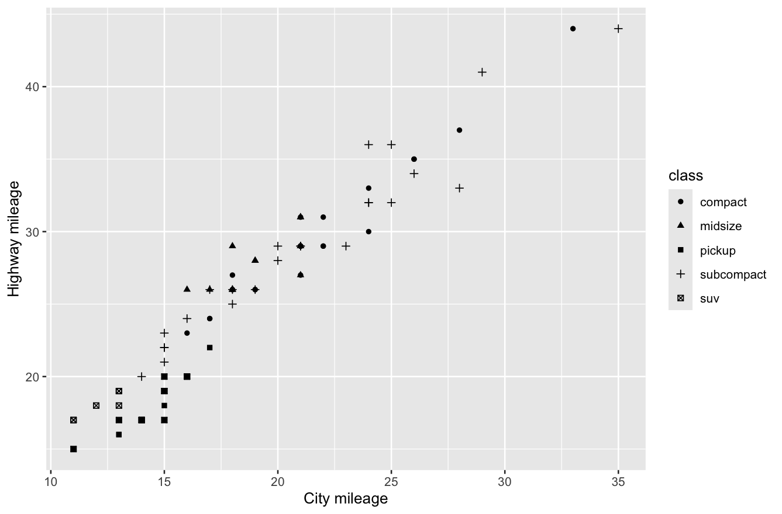
Note. The relation between city and highway mileage are shown in the above scatter plot.
7. Create a “better” plot to examine whether the relationship in the previous graph is different for different classes, using different colored lines. Make sure the lines are easy to read. As always, please copy/paste the R code and also include the actual figure(s) (with figure number, title, and note in APA style).
Hint: You can use qplot() for this but it will most likely not be as pretty as when you use ggplot(). Furthermore, depending on what you do (for example specify method = "lm" in the qplot() command), you might get a warning that some arguments are ignored or are not supported ; however, as we have seen in the class, the commands still seem to work, despite the warning.

Figure 6
The plot distribution showing the different slopes in five class
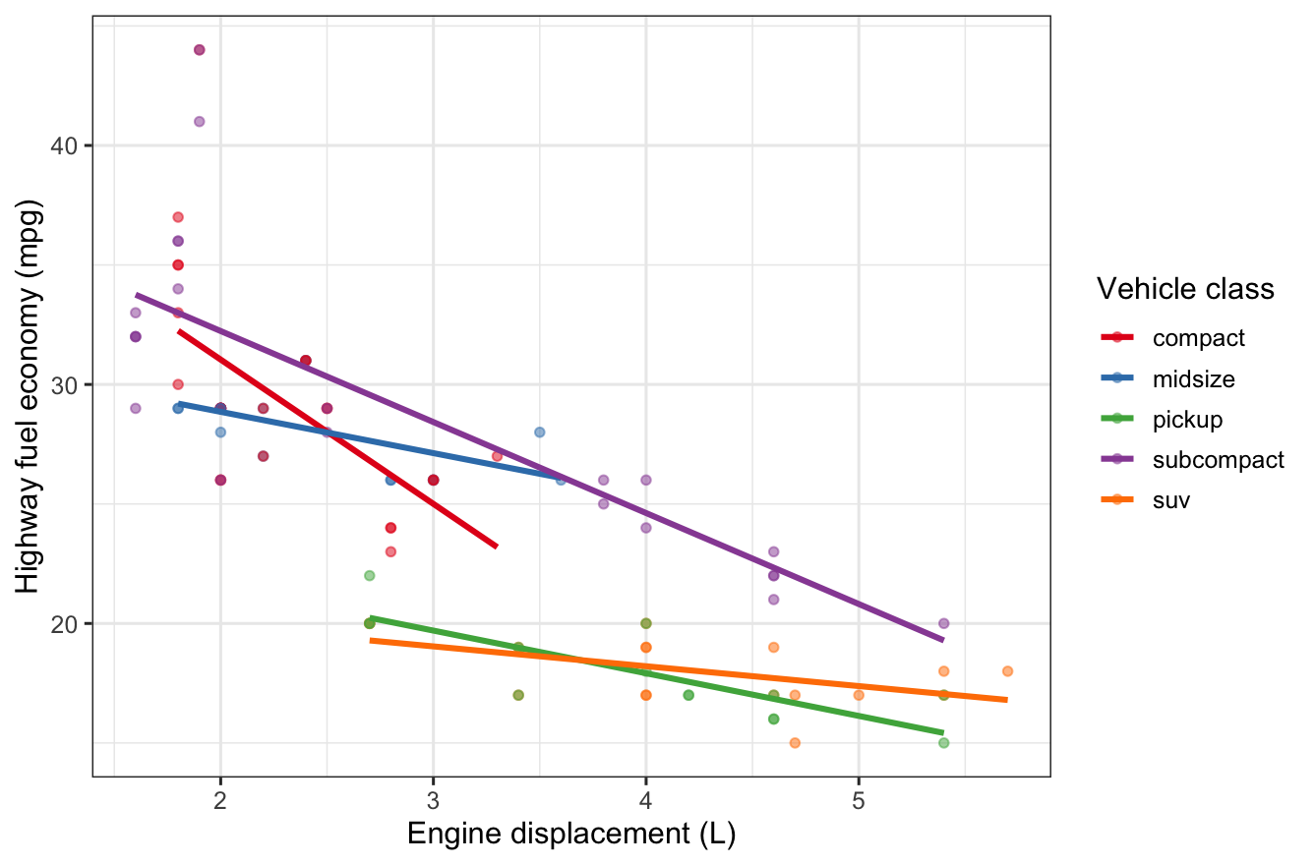
Note. The different colors represent different classes, and the slopes represent the specific relationship within the class.

PART C: Using ggplot()…finally
The ggplot() command is more flexible and versatile than the qplot() command; that flexibility (as always...) comes with a price, namely it's a bit more complicated to use and remember how this all works. However, you get rewarded with really great-looking prefessionally looking figures.

8. (a) Use the command ggplot() to create a bar chart showing the mean highway mileage for each class in mpgsmall using different colors for the various classes.
(b) Add error bars to the previous figure.
(c) Add a nice color theme from ggthemes and make the labels of the chart pretty for publication (make sure the theme can show the labels of the axes, thus do not use WSJ theme).
As always, for (a), (b), and (c) please copy/paste the R code and also include the actual figure(s) (with figure number, title, and note in APA style).

Figure 7
The bar chart distribution showing the mean highway mileage for every class
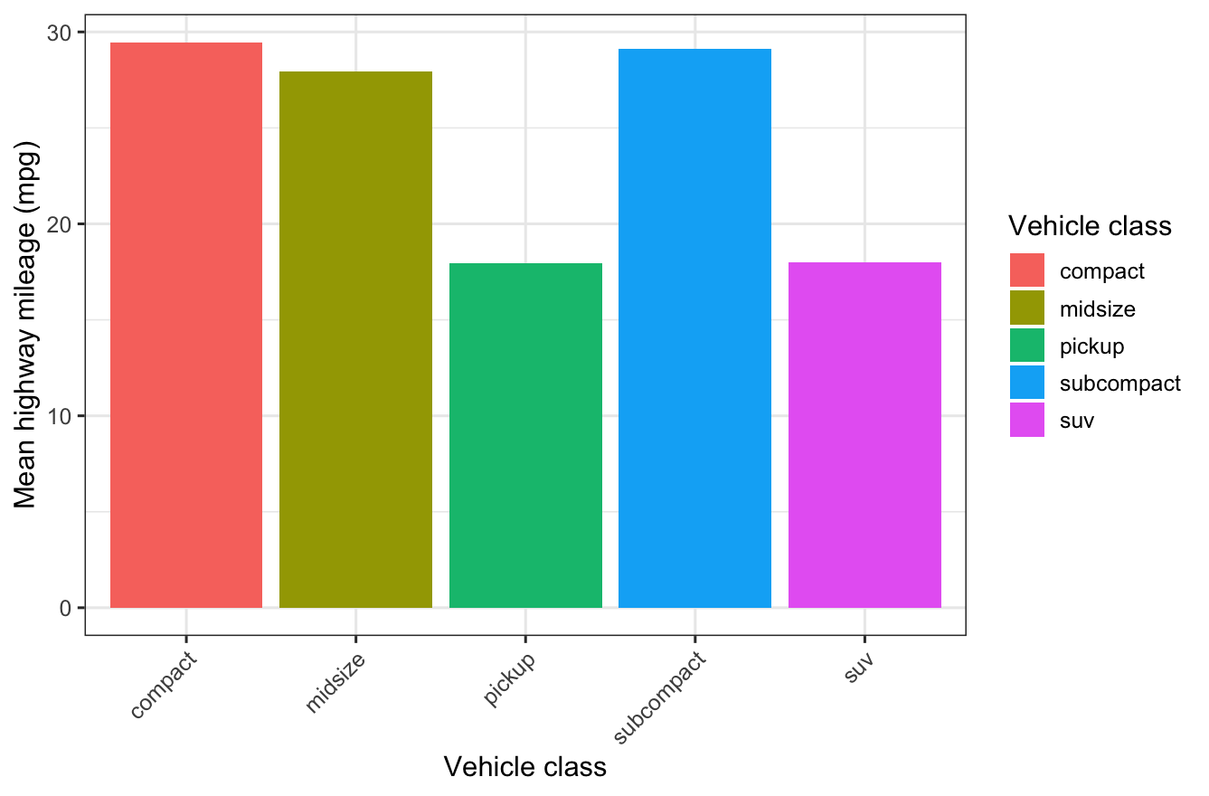
Note. The different colors represent different classes, and the height of different classes represent the mean highway mileage.
Figure 8
The bar chart distribution showing the mean highway mileage for every class with error bars
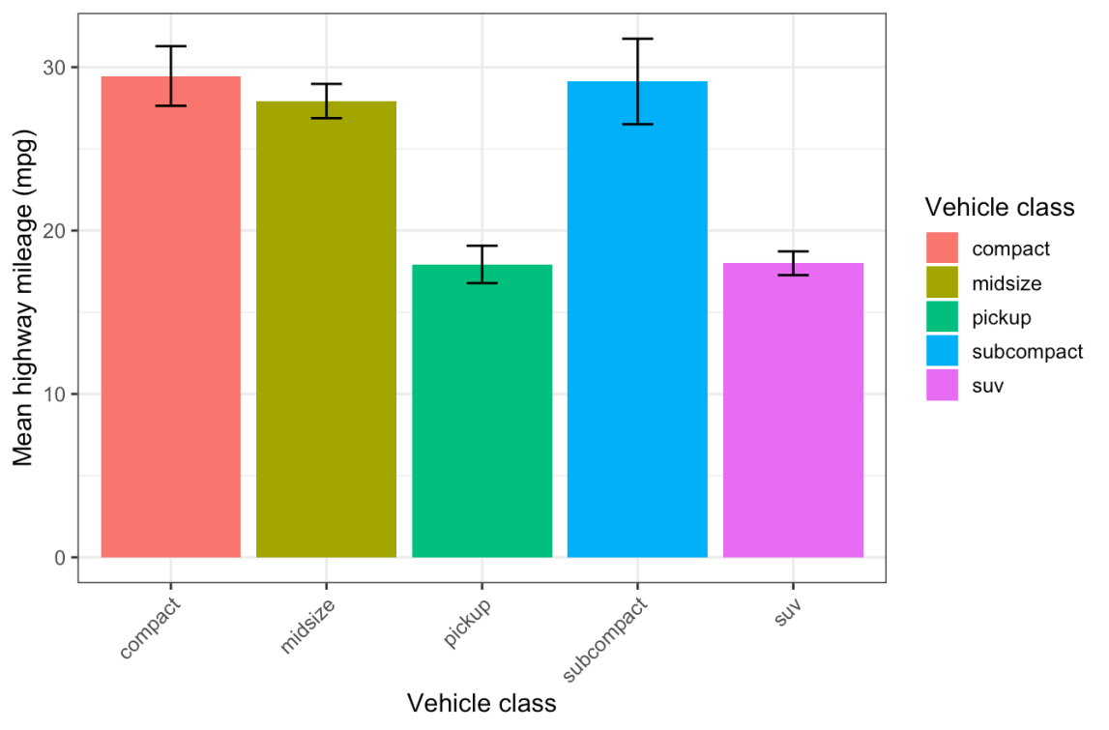
Note. The different colors represent different classes, and the height of different classes represent the mean highway mileage. The black lines represent the error bars.
Figure 9
The bar chart distribution showing the mean highway mileage for every class with error bars
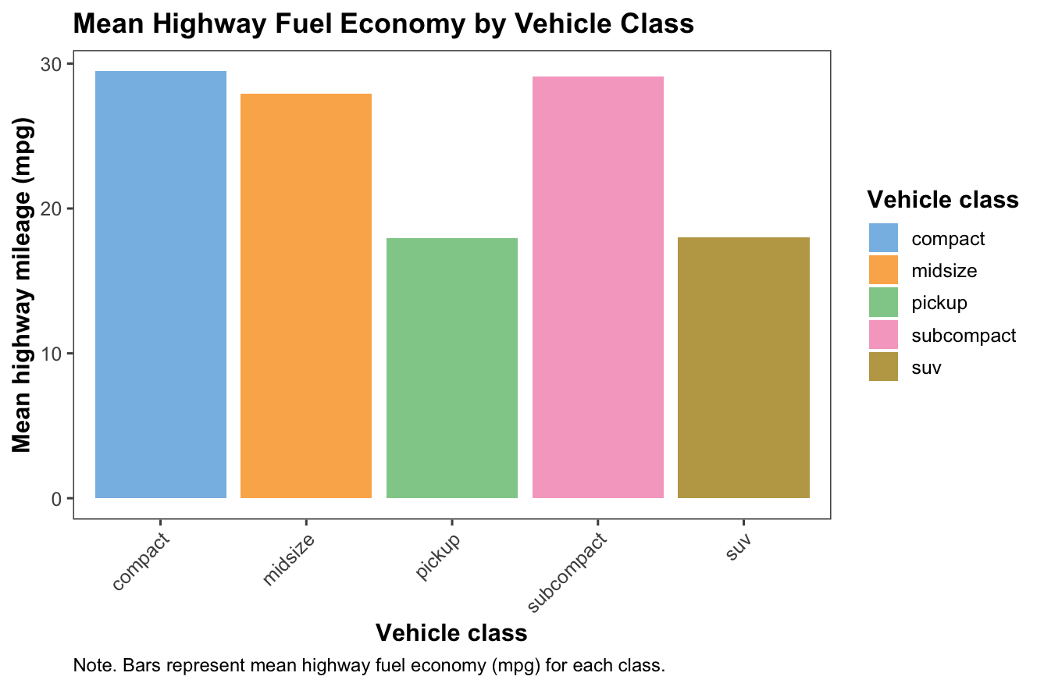
Note. The different colors represent different classes, and the height of different classes represent the mean highway mileage. The black lines represent the error bars.

9. Change the previous bar chart so that it shows the city mileage bar next to each highway mileage bar (including error bars). As always, please copy/paste the R code and also include the actual figure(s) (with figure number, title, and note in APA style).
Some hints for doing this (read them all before you start)
- Hint 1: You will need to reshape the mpgsmall dataset so cty and hwy are stacked below each other in long format with a variable coding for whether the mileage is cty or hwy.
- Hint 2: The data mgp data set (and thus also mpgsmall data set that you created) has a special format, it is a so-called tibble (this is a new format developed by the guy who also developed the ggplot2 package). It has slightly different properties than a regular data frame and therefore the reshape command will most likely give you an error. The easiest workaround is to turn the data set into a regular data frame, with something like the following command: mpgsmall_df <- as.data.frame(mpgsmall)
And then you use the data frame mpgsmall_df in the reshape command.
- Hint #3: Before you can reshape the data frame, you will need to have a column coding for the idvar in the reshape command. You can do that with this line:
mpgsmall$id <- row.names(mpgsmall)
- Hint #4: Your long data set will have a new variable coding for whether the mileage is cty or hwy. This new variable needs to be transformed into a factor in order for ggplot to be able to handle it as a discrete variable. Use the command as.factor() for that.

Figure 10
The bar chart distribution showing the mean city and highway mileages for every class with error bars
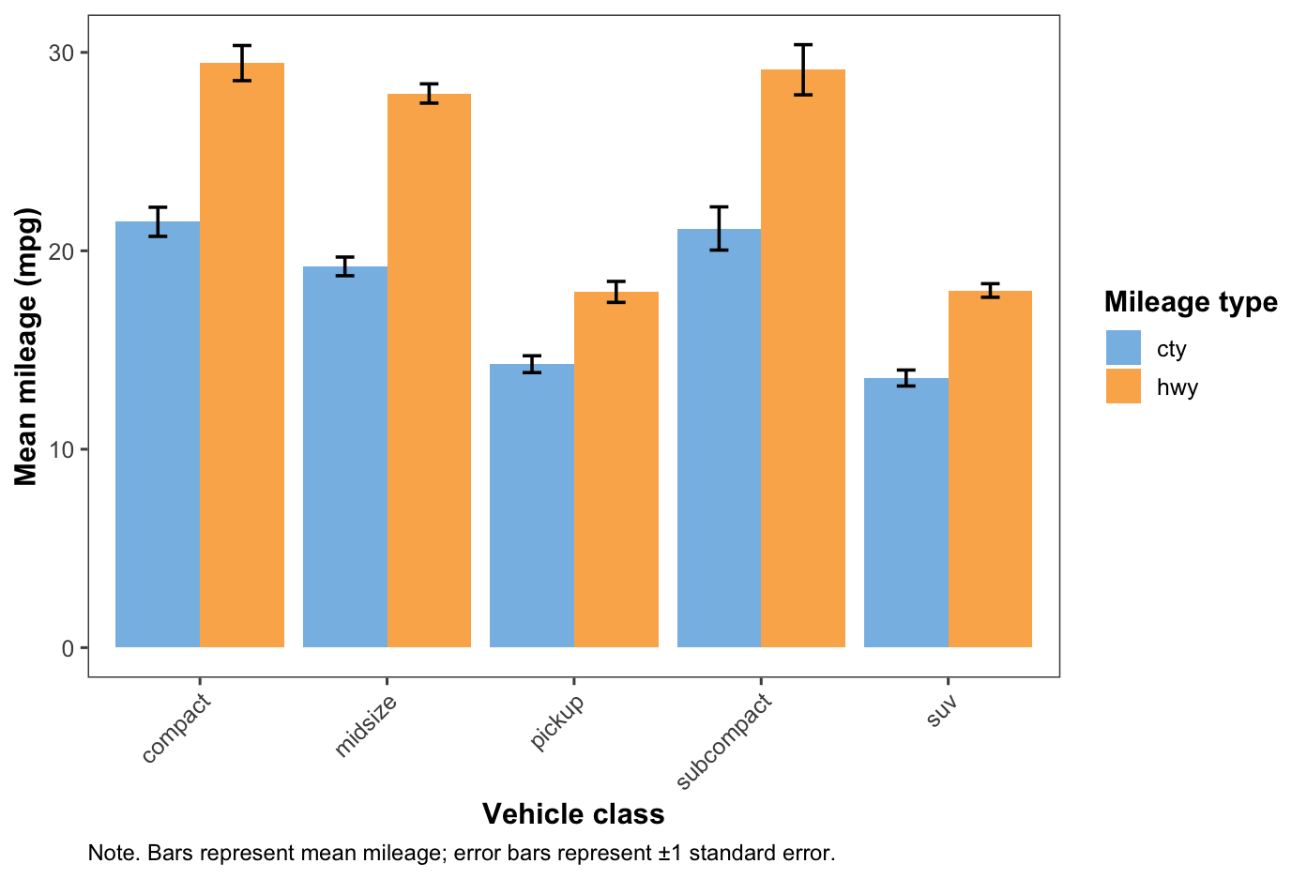
Note. The different colors represent city and highway mileage types, and the height of different types represent the mean mileage. The black lines represent the error bars.

10. Create a multiple-choice exam question with 4 answer options (1 of them the correct answer, please indicate which one) that you think is a good way to test the content of this week.
After subsetting a data frame so that only two of four levels of a factor remain, why is it recommended to call droplevels() on the subset?
A. It permanently deletes the removed rows from the original data frame.
B. It removes the unused factor levels so that plots and models no longer treat those levels as present.
C. It converts the factor into a character vector.
D. It recodes the remaining levels to numeric values.

Bonus assignment:
In week 2, I introduced the rating data set: Each participant provided 3 mood ratings, first a baseline measure, then after watching a funny video clip, and then a third mood rating watching after a sad video clip. Think about how you could best visualize the data when you want to show (a) the central tendency and distribution/spread for each condition (i.e., neutral, happy, sad) while also showing all the individual data points and--as an extra nice bonus--show for each participant how they changed from neutral to happy and to sad.
If you want to, you can try to create such an actual figure with ggplot2 (I would recommend the package ggrain to create a raincloud plot and you could look at the slides from part 2, page 28 bottom; but you can use of course also other ways to visualize this, feel free to be creative!). But if that's too tricky or too time-consuming, then just take a piece a paper and draw roughly a sketch how you might want such a plot to look like. In that case, take a photo of your drawing and insert it into your answer document.
Figure 11
The raincloud plot of participants’ mood ratings across three conditions
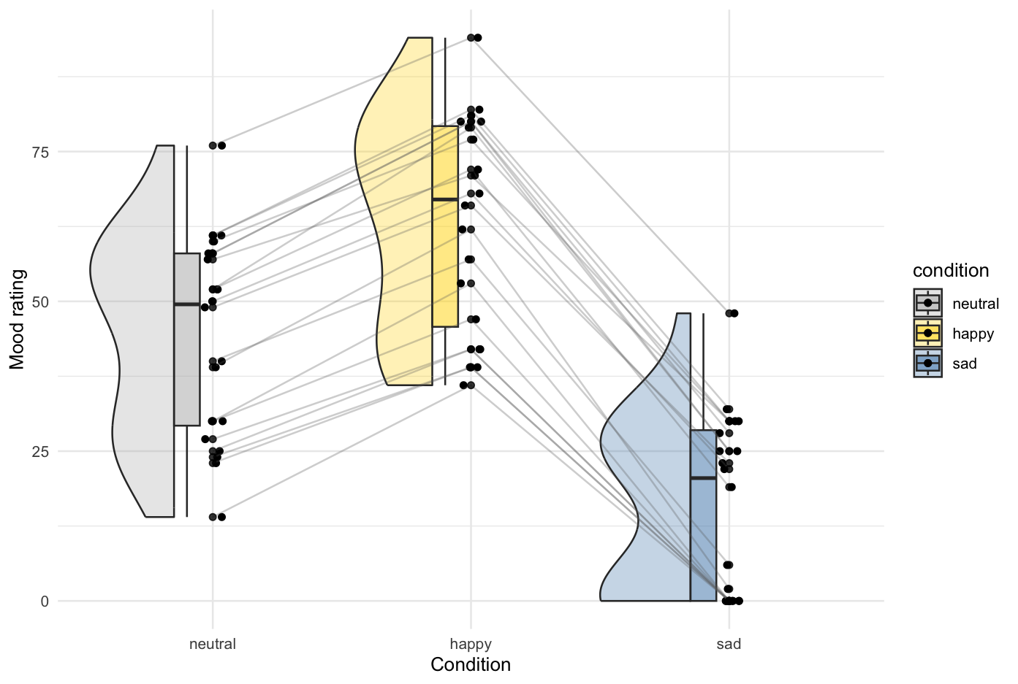
Note. The different colors represent three different mood conditions (neutral, happy, and sad), and the black slopes between each condition indicate how each participant changed from neutral to happy and to sad. The black spots represent every trial of each participant.

df <- read.csv("Rating_ExampleData.csv")
df
# change the wide to long format
install.packages("tidyverse")
install.packages("ggplot2")
install.packages("ggrain")
library(ggplot2)
library(ggrain)
library(tidyverse)

df_long <- df %>%
pivot_longer(
cols = c(rating_1, rating_2, rating_3),
names_to = "condition",
values_to = "mood"
) %>%
mutate(
condition = factor(condition, levels = c("rating_1", "rating_2", "rating_3"), labels = c("neutral", "happy", "sad"))
)
df_long

ggplot(df_long, aes(x = condition, y = mood, fill = condition)) +
geom_rain(rain.side = "l", boxplot.args = list(width = 0.1, alpha = 0.5), violin.args = list(alpha = 0.3)) +
geom_line(aes(group = pp_code), colour = "grey40", alpha = 0.3) +
geom_point(size = 1.5, alpha = 0.8) +
scale_fill_manual(values = c("neutral" = "grey70", "happy" = "gold", "sad" = "steelblue")) +
labs(x = "Condition", y = "Mood rating", substitle = "Each line = one participant") +
theme_minimal()

